Exemplar
We all have something that we think is the greatest. I think the greatest comeback in the history of the NFL was the 1992 AFC wildcard game(Bills vs Oilers). I think the greatest videogame ever created is The Legend of Zelda: A Link to the Past (SNES). Think about something you think is the greatest.
Worksheet
In my opinion these are some of the greatest things

- Musician: Arcade Fire
- Athlete: Jim Kelly
- Movie: The Godfather
- Entertainer: Richard Pryor
- Movie star: Sean Penn
- Food: Pho (Vietnamese noodle soup)
- Car Subaru: WRX
- Character: Gandalf the White
- Video game: Legend of Zelda Link to the
- Video Game Console: NES
What makes something great? Pick the three best words that make something great. Use the dictionary if you don’t know any of the words. Circle the three best.
Unique
Excellent
Best
Biggest
First
Leader
Grand
Powerful
Influential
Expensive
Chief
Fastest
Coolest
Easiest
Superior
Powerful
Outstanding
Extreme
Eminent
Distinguished
Remarkable

Which of your favorite greatest things do you think would be easiest and most effective in creating a short Photostory movie? The Nintendo Entertainment System
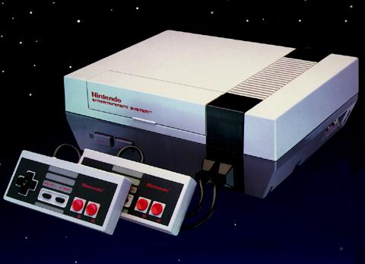

Greatest thing | 5 Ws |  | What makes it the GREATEST? Use the three words
In my opinion the greatest video game ever created is the Nintendo Entertainment system. | Who | The Nintendo corporation | The Nintendo Entertainment System (NES) is the most INFLUENTIAL, system ever made. It made home gaming fun selling 60 million systems to the first generation of console gamers. It is the most DISTINGUISHED have many good games and being ranked # 1 of all time by IGN. It is also one of the EASIEST systems to pick up and be introduced to.
 | What | The Nintendo Entertainment system
 | When | Released in 1985
 | Where | North America and Japan
 | Why | It is the best system of any era for defining console gaming

