Teenage Wasteland

Being a teen in the 20s, 30s, 40s, or 50s was a different experience than today. Using your historical knowledge and inquiry skills, create a video of you dressed up as a teen, using their slang, and talking about current events of the tim

Steps:

- Do the research and fill in the attached table
- Plan your video with a sketched story board
  - The video should include

- Historical stuff Include music, costumes, and dialogue/slang from the era. Talking about the current events of the time. Or perhaps a student from SF transported from their time to the SFDCI of 2014.

- Thoughtful shot composition: with a number of different shot types. Lots of tight shots and close ups. Not very many wide shots.

Try shooting remembering the rule of thirds. Imagine the camera divided like the picture below. Try to have the action where the lines intersect

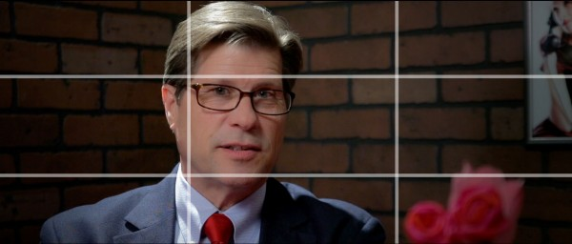

- Sound Pay attention to where your microphone is. Listen to see if you can here the voices. If you can’t hear the dialogue reshoot it so you can.

- Edit and include
  - Titles
  - Sound
  - Music
  - Credits

- Ship the product.
  - Put on USB and copy to Mr. B’s Mac OR
  - Upload to Youtube

Teenage Wasteland
Era
Fashion
Music
Fads
Slang
Transportation
For teams
Blockbuster Cultural events
Major Events that effected teens

