Best Practices in Social Media

IDC Beckett 2014

According to the MIGHTY WIKIPEDIA: "a best practice is a method or technique that has consistently shown results superior to those achieved with other means, and that is used as a benchmark. In addition, a "best" practice can evolve to become better as improvements are discovered."

In her book Powerfriending Amber Mac suggests the ABC rule of social media for business
- Authenticity
- Bravery
- Consistency

In the Office of the Privacy Commissioner of Canada’s graphic text Social Smarts, Privacy, The Internet and You. They suggest 10 rules to protect your privacy online

- Think before you click!
- Know who your friends are
- Tighten your privacy settings
- Avoid disclosing your location
- Don’t share your password and change it regularly
- Trust your instincts
- Understand new features such as geo-tagging before you try them
- Be aware of your online reputation
- Protect your privacy, as well as that of your friends
- Be discreet

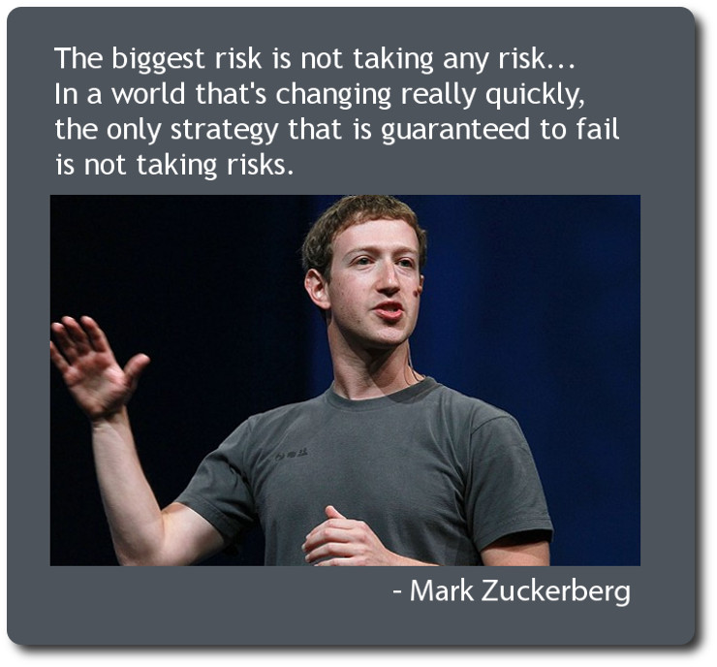

Challenge | Create a set of best practices for a social media  To an audience of high school students  A list of 5 moves to make on one specific social media  Eg Facebook, Vine, Snapchat, Twitter, foursquare, and more  I choose ______________________
Product | Video: 3 Minutes in length  Groups of two  Shows the “best practices” of your chosen social media | Requirements:  This video should include titles, music, and narration. You should include varied shots including close up, mid, and wide.  Software: Do it on iMovie on the iPad,
 | Pamphlet: 6 panels minimum.  Solo  Shows the “best practices” of your chosen social media | Requirements:  The pamphlet should include a catchy headline, images and text combined to sell your message which is evenly distributed throughout the brochure. 12 point font. Printed in colour (go to Staples if need be)  Software Word, Pages, Publisher
 | Bitstrips: 10 panels minimum.  Solo  Shows the “best practices” of your chosen social media | Requirements:  This comic should be 10 panels in length include dialogue, facial expressions.  It should have backgrounds, different characters.  Make it like the government comic…except good

