Topic Ideas For Quickie Presentation
Shipbreaker | Into the Wild
- Drug abuse… Richard Lopez Shipbreaker  - Climate change  - Specific places that would be effected…  - Genetic engineering Tool? Is a Tool Possible?  - Crispr gene editing technology  - Paolo Baccigalupi  - Antibiotic resistance  - Family issues: abusive parents  - Clipper ships  - World’s most dangerous jobs | - Specific animals or plants native to Alaska:  - Grizzly/Kodiak bears, Orca, Caribou…  - Human interference with natural world of Alaska.  - First Nations peoples in Alaska and BC (Tinglit, Haida, and more)  - Exxon Valdez oil spill  - Subsequent revelations about the McCandless family, about the seeds  - Shenandoah or other American natural wonders that McCandless encountered  - History of the gold rush  - How to survive in the wild  - Jon Krakauer  - Hippies  - Divorce  - Money?  - Family issues: abusive parents
Novel Study Presentation
ENG4C – Beckett 2017

Slides
Title slide  Topic  Name  Photo | 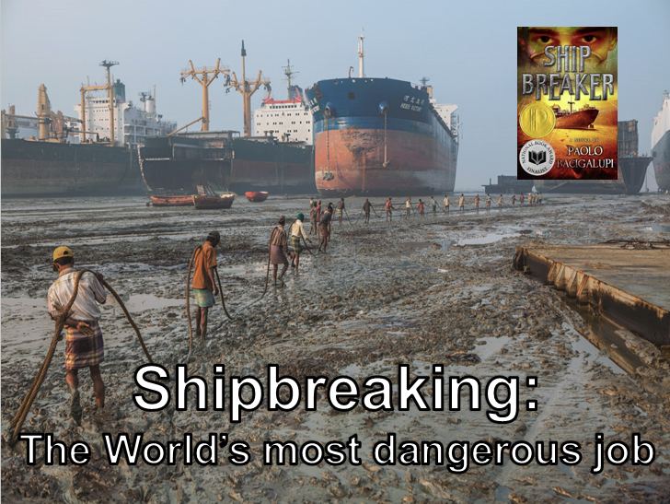
Book Recap  Summarize the details of the book in a tweet sized amount of text | 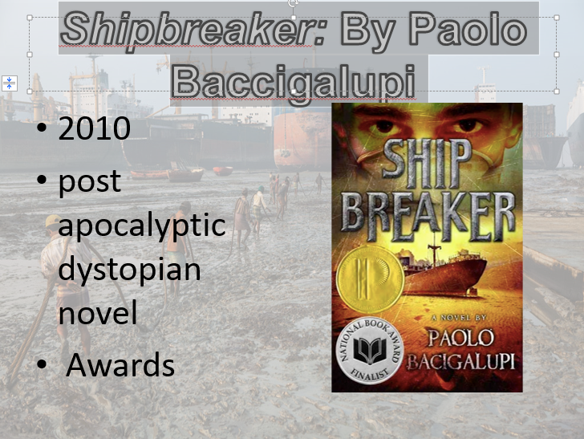
Topic part 1  Introduce the topic | 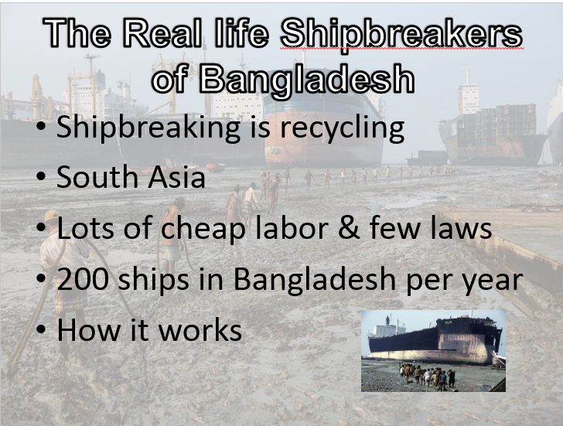
Topic part 2  Expand on the topic, consider including video clips and other multimedia | 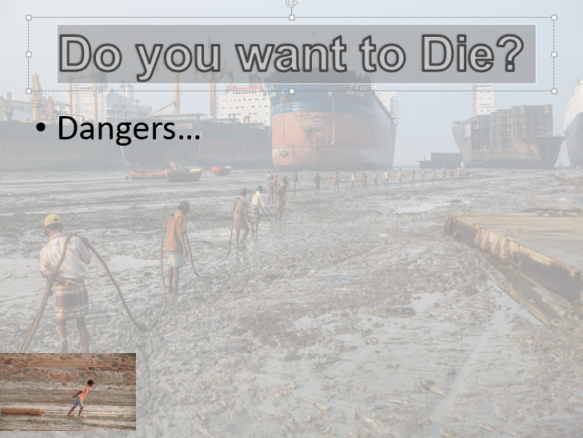
Topic part 3  Continue to expand on the topic. Is there a solution to the problem? | 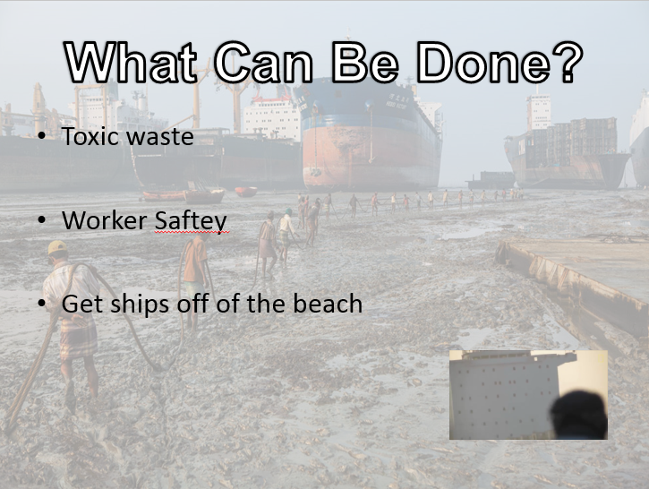
Reflection  Summarize and offer your take | 