Nice Car Man!
Examining the early evolution of the automobile

Fact: The Stutz Bearcat is one of the first sports-cars. Mr. Burns from the Simpsons owned one!!

- Choose a vehicle from the 1920s:
Ford | GM/Chev | Buick | Dodge | Studebaker | Mitsubishi | Rolls Royce | Packard | Stutz
- Model T  - Model A | - GMC Truck  - Chevrolet Model D  - Oakland Model 212 All American Landaulette Sedan 1929 | - 1920 buick model 44 | - 1927 Dodge Brothers Series 124 sedan  - 1924 Chrysler 6  - Chrysler Imperial  - 1929 Desoto | - Big Six | - Model A | - Silver Ghost  - Phantom | - Fourth Series Roadster | - Bearcat  - 8-cyilinder

- Research the vehicle and create a one page ad that emphasizes features of the vehicle:
- What are the basic features and options available
- What is the cost of the vehicle
- Include a picture of the vehicle
- Use a catch phrase
- Save and print your work

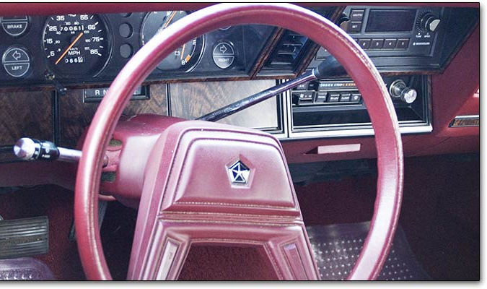
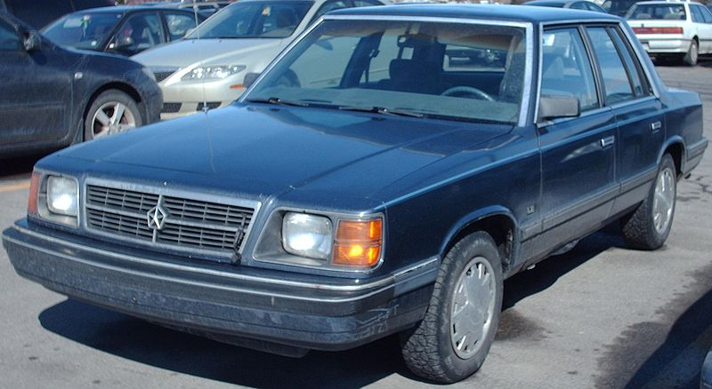
Features
- Front wheel drive
- 90 horsepower engine
- Electronic fuel injection
- AM/FM radio with optional cassette deck with auto reverse
- Map light
- Bench seating
- Cigarette lighter and ashtray

Impress all of your friends with the best six-passenger mid-size car on the planet…the Dodge Aries. The Aries says one thing to people as you drive by: “I like the cool stuff.”
Head to head not even the Pontiac 6000 or the Chevrolet Celebrity can touch the Aries
1988 Dodge Aries starting at $5880

