Exam Review

Format

- Media Analysis (Video Clip)
- Terms (Multiple choice)
- Poetry Analysis (choose 1 of 2)
- Sight Passage
- Paragraph Answers

Terms

- Persona – mask. Literary and psychological (v for vendetta? The handler, Chicxulub, the Matrix, the life of anyone, strange wine, black destroyer)
- Liminal Beings – a being in two states (a bridge or door figure) Kane’s son (the alien, Garson Poole the electric ant, Willis Kaw/Plydo, Neo, Gandalf the White/grey)
- Thought Crime – 1984 thinking something unorthodox. Unusual
- Dystopia – a hellish future – the opposite of a perfect utopia. 1984, matrix V for Vendetta, Strange Wine, lots of movies and shows. A warning or a criticism of current society.
- Cautionary Tale – see dystopia,
- Telescreen – 1984(NSA) a propaganda tv that is always on and watches you (you never know when) all the time. The physical jerks (morning stretches)
  - Propaganda
  - Surveillance
- Guy Fawkes - tried to blow up the Parliament Buildings in England 1605 Nov 5. Religious reasons.
- Ingsoc 1984 a shortening newspeak version of the word English Socialism (party and philosophy)
- Newspeak- modified version of the English language intended to prevent thought crimes. In other words a way to control minds.
- Comic relief – When some thing funny happens after something serious or brutal happens in a play. Macbeth the Porter
- Dramatic Irony – Audience knows something the characters don’t know
- Tragic Flaw – heroes one major flaw—Macbeth ambition
- Marlovians Oxfordians and Baconians – could be the real writer of Shakespeares plays
- Great Chain of Being - Shakespeare
- White Rabbit / red pill – a symbol of trying to find the truth. Live a wide awake existence (allusion version to Alice and Wonderland)
- Space Truckers – the aesthetic of Alien a science fiction movie. Blue collar folks in space
- Totalitarianism –see chart
- Tyranny – proto totalitarianism a king or monarch that has total control. Can be synonymous with Totalitarianism.
- NSA
- Prism The
- Emjambment
- End stopped
- Caesura

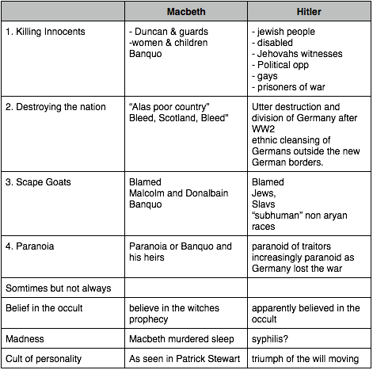

Totalitarian regimes | 1984 example from text
Dominant Ideology | -tenets of Ingsoc. English Socialism  The party is INGSOC. The country Britain is called Airstrip 1. A part of Oceania. North and South America and some of Europe.  War is Peace. Freedom is Slavery. Ignorance is Strength  The party controls the society in 1984. 85% proles. 13% outerparty 2% inner party. The inner party controls the society.  Everyone must believe in the party and go through the daily, weekly, and yearly routines and rituals. The minute of hate, hate week and so on.
Single party | Ingsoc 1984  Norsefire V for vendetta  Baath Iraq Syria  Bolsheviks (stalin/lenin)  Nazi Germany
Secret police | Thought Police  Fingermen (V for Vendetta)  SS – Nazi Germany  Brown Shirts (Italy)
Monopoly on information | Ministry of Truth…
Planned economy | Shoelaces, chocolate, gin,  All poor quality, all

- Explain the possible meanings of the title (4 marks).

- Make three literal statements about the poem (3 marks).

  - What is the meaning of the poem
  - What is the message
  - What is the tone

- Identify and explain three poetic devices (6 marks).

- Is this poem good? Why or why not? (5 marks)

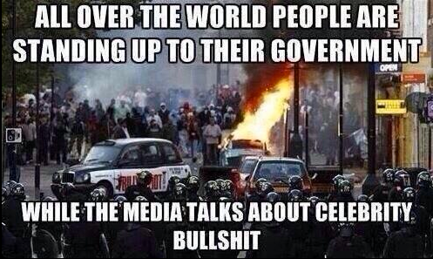

1. Examine the picture above. Is the media a Ministry of Truth?

2. How is Lenin’s maxim “the heart on fire, the brain on ice” an apt description of the English dystopia depicted in either

- Airstrip One under Ingsoc in 1984
or
- England under Sutler and Norsefire in V for Vendetta.

3. How does Macbeth’s awful tyranny predict totalitarian regimes of the 20th century?

4. Does Macbeth die a heroic death?

4. How does a liminal being operate within science fiction stories? (Cane’s son, Neo, Poole, Pete)

- Why do science fictions protagonists end their lives?

Must answer one below

- How are “fair is foul and foul is fair” the theme words of the course (that under a appealing façade there is a terrible ugliness)

- According to the lead characters in the texts we examined is it better to live in ignorance or die with awareness?

