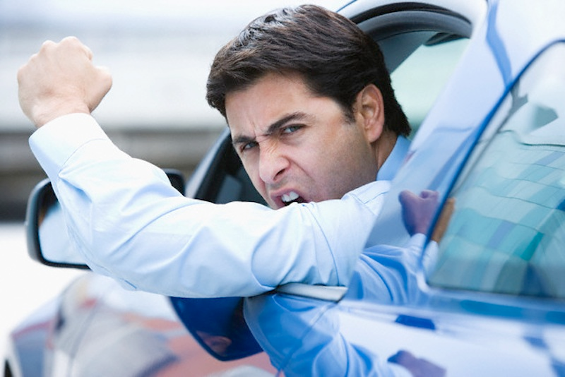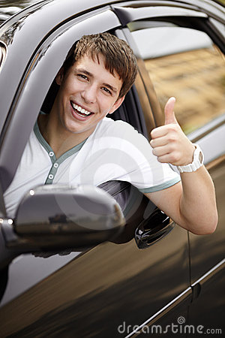
Questions from the Drivers Handbook
From the section:

Safe and Responsible Driving
Getting Ready to Drive

In The Text Questions (these Questions are directly in the text. They are only right if you quote them directly)
- Why is it important to watch for warning lights on your vehicle?
- What should you be able to do when operating the simple controls of your vehicle?

Get into Position

- How close in front of the vehicle should the driver be able to see?

Find your Blind Spots

- What are blind spots?
Author and me Question (use your opinion and the text to write a short paragraph answer.

- What situation would you have to check your blind spot on the left? What about the right?

Thinking Question
Think about this one and use your smarts
- Why should you check your right blind spot when turning right at a stop?

Fasten your seat belt

In The Text Questions
- What can the cops do to you if you don’t have your seatbelt done up?

- Other than Mrs. Beckett making me sleep outside, what are the consequences if I don’t buckle up my kid?

- Why should I not buy a used child car seat?

Turn on Headlights at night
Questions from the Drivers Handbook
From the section:

Safe and Responsible Driving
Driving Along

- What do people mean when they say you should have your hands at 10 and 2?
Thinking Question

- Why would experts be recommending 9 and 3 instead of 10 and 2?

Obey Speed Limits
- How fast can you drive when the speed limit is not posted?
- What is safe following distance? How can a driver tell if she is following at a safe distance?

Sharing the road with large vehicles
- What problems do long trucks offer drivers?

Sharing the road with pedestrians
- Is it safer to be a pedestrian on a country road or a busy city block?
Thinking Question

Sharing the Road with cyclists

- Even a parked car can be a danger to a cyclist. How is this possible?

Sharing the Road with Farm Machinery

- What sign indicates that a vehicle is a slow moving piece of farm equipment?

- What time of year do you think I found the most frustrating when I drove from Kemptville to North Dundas on Highway 43?…Why? Link to map
Thinking Question

Sharing the Road with Pedestrians
- What are the two ways a driver can avoid accidents with pedestrians?

Stopping for school buses

- How much jail time can you get for not stopping for a bus?
- Where is a unique place school buses have to stop that cars do not?

- Have you ever had a scary moment riding in a school bus? What happened and why was it so scary?
Thinking Question

Driving at Night or in bad conditions
- What is overdriving your headlights? Why is it dangerous?
- What steps should you take for foggy weather?

Dealing with Particular Situations

- What are the maximum penalties for street racing or aggressive driving for a first time offence?

