Canada’s Worst Moments
While Canada is the best nation on the planet; we, like any other nation, are not perfect. We have done several shameful things in the past that we should remember along with our proud moments

Event | The skinny
Japanese Internment | Canadians of Japanese decent were sent to camps and all their stuff was sold by the Canadian gov’t during WW2
Barring European Jews from immigrating in the early 40s | The Jews of Europe during the holocaust and after were sent away by Canada (one official said that “none is too many”)
Residential Schools | First nations kids were taken from their parents and brought up in schools to be like “white Christians.” (on top of this Abuses of all kinds took place)
The Somalia Affair | Canadian soldier tortured and killed a Somailian teen in the early ninties.
Chinese head tax | Chinese people couldn’t immigrate to Canada unless they paid a fee.
Bomber Command | Canadian bombers in WW2 intentionally bombed Germany civilians (including women, children, and the elderly) in order to ‘knock the fight’ out of the German people.
Some other option | Talk to your teacher…
Your Job: Investigate and create a Poster on one of Canada’s worst human rights abuses and war crimes of the 20th century.

Include:
- Design elements (see below)

- Headings (one paragraph each) including

  - Basic facts - who, what, when, where
  - Analysis - why did it happen?
  - My opinion - what do I think of this shameful moment?
  - Never Again - what can we do to stop this from happening again?

- Pictures - at least 4
Design Elements You Must Include
Your poster must be typed, with titles and headings. The paragraphs and other elements should be square, centered, and symmetrical. Use black construction paper to frame major elements.

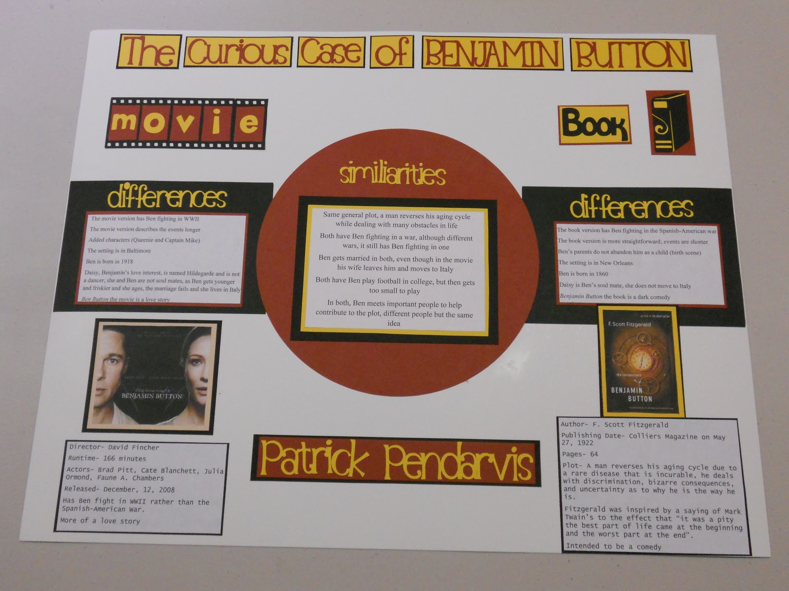
That poster is dopealcious
Black framed
Titles & Headings
Square, centered, and symmetrical
Typed

