Essays At A Glance
Parts of the Essay | Description
Thesis Statement | The thesis is the central controlling idea of your essay. Your main idea boiled down into one or two sentences
Opening-Intro | The introduction introduces your reader to your general topic, the body points, and clearly states the thesis. All of this is done in order which is followed throughout the essay.
Body | The proof or example paragraphs. This is organized like a mini essay with a topic sentence which is like a mini thesis statement.
Conclusion-Outro | The conclusion wraps up restates and states the wider importance of your findings or your opinion

Formatting Basics Checklist
- 12 point font (regular not wacky fonts – never comic sans) | - Stapled top left hand corner
- Double spaced | - Regular letter sized paper
- A Works Cited page | - A title page with an original title
- Pages numbered and student’s name in the header (top margin of the page)  - Beckett 1/5 (Author = Beckett, Page = , number of pages = 5) | - No personal pronouns especially “I”  - You cannot use contractions (it’s especially)

Paper Title
(double-spaced, in bold, centred)

(begin at centre)

Student’s Name
Course Code and Section
Teacher’s Name
Due Date

Matilda Murphy -Murphy 1-
Mr. Dunkleblum
ENG3U
April 30, 2010

Mad, Bad, and Dangerous to Know:
General Zaroff’s Insanity in “The Most Dangerous Game”
It is important that your essay follow the appropriate format. A formal essay that follows the Modern Languages Association’s style guide (M.L.A.) should look like what you are now reading. In this brief template you will learn about format, quotations and references.

Parts of the Essay
Thesis Statement | The thesis is the central controlling idea of your essay. Your main idea boiled down into one or two sentences

What is a Thesis
- A thesis is a concise supportable statement of your central opinion, judgment, or idea about the focused topic
- A thesis is based on your thinking or your research.
- A bad essay comes from a bad beginning–moreover a bad thesis
- An essay is like a debate. You argue one side–Imagine your reader arguing the other.
- The thesis is your essay’s life and spirit

How to write a Thesis

Con – this is your concession to the opposition’s point of view. To put an argumentative edge on your thesis statement, and show the reader you have considered the situation from more than one perspective | Assertion – Come up with a point of view. What’s your opinion on the material at hand? | Pro – this is your reason for this belief. Provide your reader with a reason—one that is broad enough to encompass all of your arguments—for your position
Example: Although some suggest that Chuck Palahniuk’s Fight Club is an endorsement of fascism, Fight Club is truly a commentary on the dissatisfaction experienced by Generation X in the 1990s and the dangerous places such a malaise could lead.

Parts of the Essay
Opening-Intro | The introduction introduces your reader to your general topic, the body points, and clearly states the thesis. All of this is done in order, which is followed throughout the essay.

What is an Intro
- Your Opening Paragraph must contain your main idea—Your thesis Statement
- The most emphatic place for your main idea is the last sentence of your opening paragraph
- Therefore your first sentence should be a general statement piquing the reader’s interest.
- The intro paragraph is like a funnel funneling from general to specific.

How to write an Intro (Write a sentence or two for each Chevron below)

Parts of the Essay
Body | The proof or example paragraphs. This is organized like a mini essay with a topic sentence, which is like a mini thesis statement.

What is the body?
- The body paragraph is the standard paragraph of an essay. It is like a mini-essay in itself.
- Each body paragraph should be tied to the paragraphs immediately before and after it
- Each topic sentence must somehow hook onto the paragraph above it, must include some word or phrase to ease the reader’s path: a transition.
  - You may simply repeat a word for the sentence that ended the paragraph just above

  - You may bring down a thought generally developed

  - Or you may use one to the Transitional Words & Phrases (see the handout)

How to write the body (Write a sentence or two for each Chevron below)

N.B. – Order your arguments in a logical and effective sequence. Always begin and end with your best and most forceful arguments and put the weaker ones in the middle. You can then begin and end with a good impression

Parts of the Essay
Conclusion-Outro | The conclusion wraps up restates and states the wider importance of your findings of your opinion

What is the conclusion?
- If the beginning paragraph is a funnel the end paragraph is a funnel upside down
- The thought starts out moderately narrow and pours out broader and broader implications
- The conclusion answers the “SO WHAT?” question
- If you have presented your chain of reasoning clearly your conclusion will arise naturally from the evidence you have presented. It will not merely repeat that evidence, but clarify its significance”

How to write the conclusion (Write a sentence or two for each Chevron below)

N.B. – do not add entirely new information you should have prepared your reader for and statements you make at this point

The Whole Essay
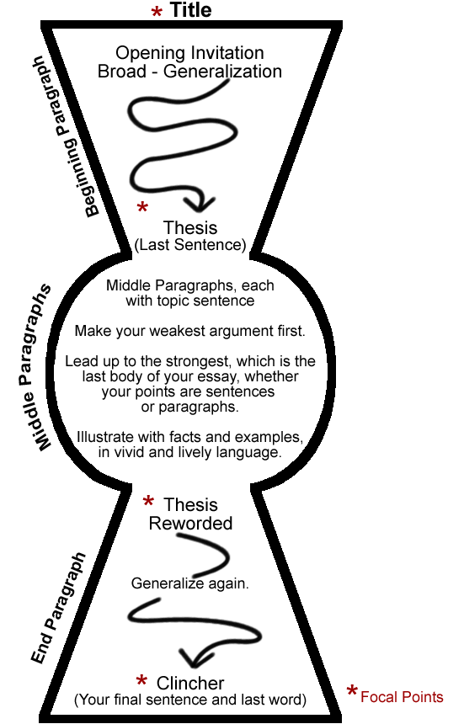
Sharpen your thesis statement in one sentence

Put your weaker points in the middle

Your beginning paragraph should seem like a funnel

Your middle paragraphs should seem like mini essays with their own beginnings and ends

The final paragraphs should work like an inverted funnel broadening and enhancing your thesis

