Juror | Description | Picture from Film
Juror 1 | Even handed  Non-confrontational, serves as the foreman of the jury. He is serious about his authoritative role, and wants to be as fair as possible. | 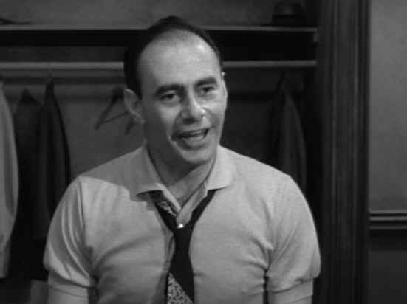
Juror 2 | Timid  He is the most timid of the group. Just how timid? Well, this will give you an idea: For the 1957 adaptation of 12 Angry Men, director Sidney Lumet cast John Fielder as Juror #2. (Fielder is best known as the voice of “Piglet” from Disney’s Winnie the Pooh cartoons). Juror #2 is easily persuaded by the opinions of others, and cannot explain the roots of his opinions. | 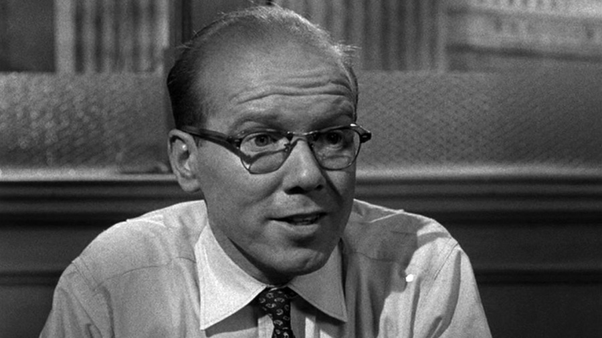
Juror 3 | Sadistic and aggressive  In many ways, he is the antagonist to the constantly calm Juror #8. Juror #3 is immediately vocal about the supposed simplicity of the case, and the obvious guilt of the defendant. He is quick to lose his temper, and often infuriated when Juror #8 and other members disagree with his opinions. He believes that the defendant is absolutely guilty, until the very end of the play. | 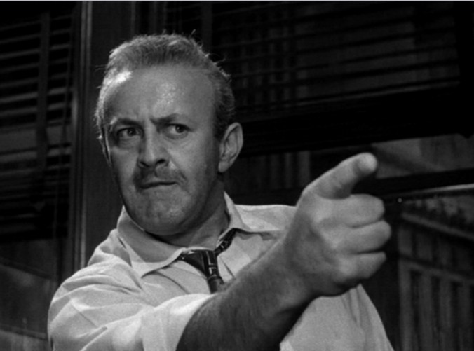
Juror 4 | Logical and quiet  A logical, well-spoken stock-broker, Juror #4 urges fellow jurors to avoid emotional arguments and engage in rational discussion. He does not change his vote until a witness’s testimony is discredited (due to the witness’s apparently poor vision). | 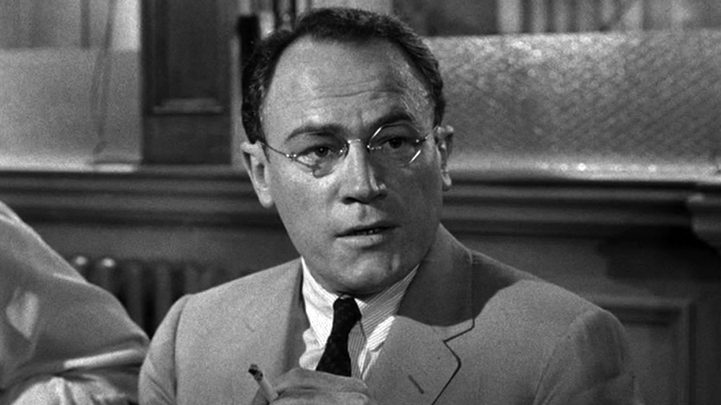
Juror 5 | Sees different perspectives. Is from a poor area.  This young man is nervous about expressing his opinion, especially in front of the elder members of the group. He grew up in the slums. He has witnessed knife-fights, an experience that will later help other jurors form an opinion of “not guilty.” | 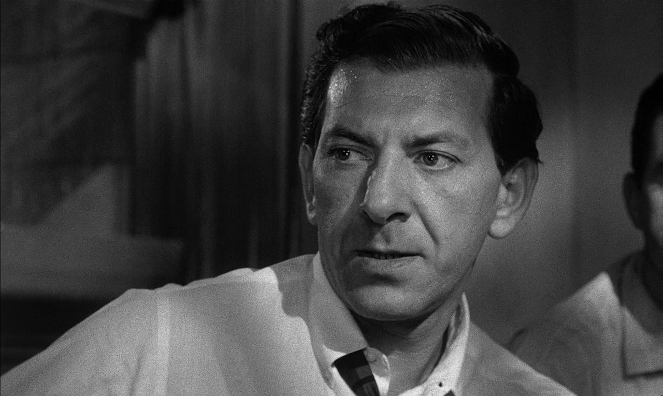
Juror 6 | Working class, blue collar guy  Described as an “honest but dull-witted man,” Juror #6 is a house painter by trade. He is slow to see the good in others, but eventually agrees with Juror #8. | 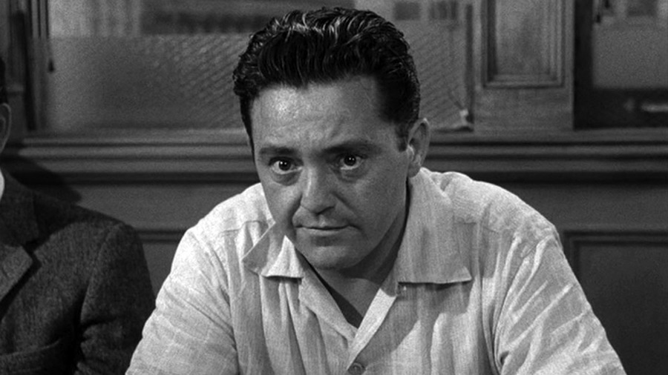
Juror 7 | Sports fan doesn’t take it seriously  A slick and sometimes obnoxious salesman, Juror #7 admits during Act One that he would have done anything to miss jury duty. He represents the many real-life individuals who loath the idea of being on a jury | 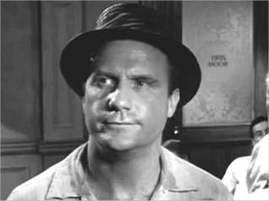

Juror 8 | Thoughtful skeptic. Is not convinced of the accused’s guilt  He votes “not guilty” during the jury’s first vote. Described as thoughtful and gentle, Juror #8 is usually portrayed as the most heroic member of the jury. He is devoted to justice, and is initially sympathetic toward the 19-year-old defendant. At the beginning of the play, when every other juror has voted guilty he is the only one to vote: “not guilty.” Juror #8 spends the rest of the play urging the others to practice patience, and to contemplate the details of the case. A guilty verdict will result in the electric chair; therefore, Juror #8 wants to discuss the relevance of the witness testimony. He is convinced that there is reasonable doubt. Eventually he persuades the other jurors to acquit the defendant. | 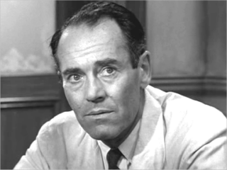
Juror 9 | Old man stands up for what he thinks is right. Doesn’t like bullies  Described in the stage notes as a “mild, gentle old man, defeated by life and waiting to die.” Despite this bleak description, he is the first to agree with Juror #8, deciding that there is not enough evidence to sentence the young man to death. Also, during Act One, Juror #9 is the first to openly recognize Juror #10’s racist attitude, stating that, “What this man says is very dangerous.” | 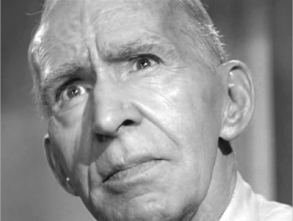
Juror 10 | The racist  The most abhorrent member of the group, Juror #10 is openly bitter and prejudice. During Act Three he unleashes his bigotry to the others in a speech that disturbs the rest of the jury. Most of the jurors, disgusted by #10’s racism, turn their backs on him. | 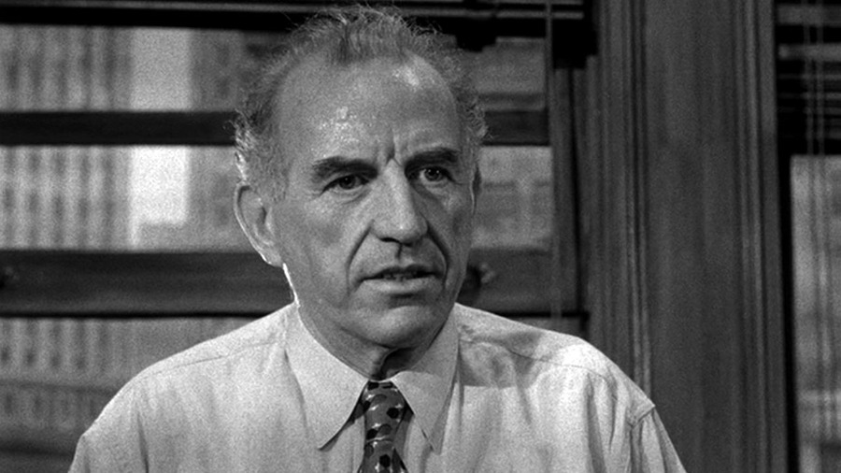
Juror 11 | The immigrant. Thoughtful and smarter than the others give him credit for  As a refugee from Europe, Juror #11 has witnessed great injustices. That is why he is intent on administering justice as a jury member. He sometimes feels self-conscious about his foreign accent. He conveys a deep appreciation for democracy and America’s legal system. | 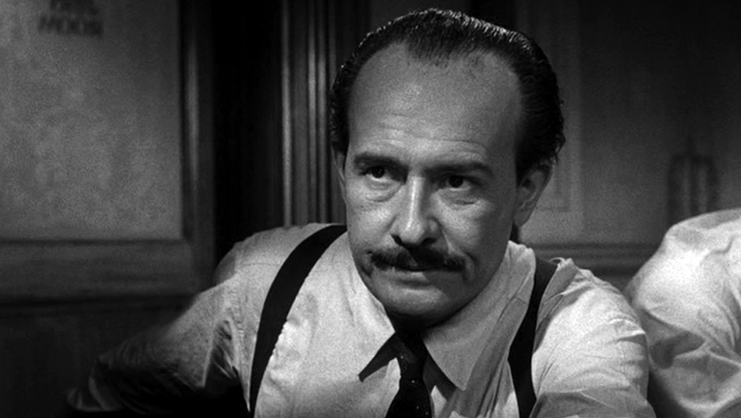
Juror 12 | An average guy  He is an arrogant and impatient advertising executive. He is anxious for the trail to be over so that he can get back to his career and his social life. | 