Heavy Metal History
Examining the effect of history on popular culture

Fact: Many classic metal tunes are based in the history and historical events you studied in this class!

Your Job:
- Choose one of the songs listed below. Check the historical event that is presented in the song—make sure you pick a historical event that you are interested in. You are studying how history is shown in the song. You ARE NOT studying about the band!!!!
Band | Song | Historical Event
Metallica | Disposable Heroes | World War One Trench Warfare
Iron Maiden | Gangland | 1920s gangsters
Metallica | One | War Disabilities “Johnny Got His Gun”
Slayer | Angel of Death | The Holocaust and Dr. Joseph Mengele
Iron Maiden | Aces High | Battle of Britain (World War two flying aces)
Megadeth | Rust in Peace… Polaris | Nuclear War and the Polaris Missile

- Listen to the song and read the lyrics. Think about what the lyrics mean and how they relate to history.

- Fill in the five W’s chart. You must use at least two different resources for your information. This means it cannot all come from Wikipedia. Please write down where you got your info in the “source” column.

- Complete the “PQP” worksheet. Please use complete sentences as much as possible.

- Save your work, print it.

Five W’s Chart
Song_____________________________________ Name:________________________________________
Five Ws | Historical event: | Source
Who
What
When
Where
Why
PQP chart:
Positives | Questions | Possibilities
List two accurate historical facts in the song:  How do the guitars, drums, and singing reflect the historical event?  Any other overall positives | List any historical mistakes:  How does the music take away from the historical event in any way?  Any other overall negatives? | Are there any historical facts that you would add to the song?  Is there any way that the music could be improved to reflect the historical event  Are there any other ways the song could be improved

Disposable Heroes by: Metallica
Bodies fill the fields I see, hungry heroes end
No one to play soldier now, no one to pretend
Running blind through killing fields, bred to kill them all
Victim of what said should be
A servant `til I fall
[Chorus:]
Soldier boy, made of clay
Now an empty shell
Twenty one, only son
but he served us well
Bred to kill, not to care
Do just as we say
Finished here, Greeting Death
He's yours to take away
Back to the front
You will do what I say, when I say
Back to the front
You will die when I say, you must die
Back to the front
You coward
You servant
You blindman
[End Chorus]
Barking of machinegun fire, does nothing to me now
Sounding of the clock that ticks, get used to it somehow
More a man, more stripes you wear, glory seeker trends
Bodies fill the fields I see
The slaughter never ends
[Chorus]
{Why, Am I dying?
Kill, have no fear
Lie, live off lying
Hell, Hell is here} x2
I was born for dying
Life planned out before my birth, nothing could I say
had no chance to see myself, molded day by day
Looking back I realize, nothing have I done
left to die with only friend
Alone I clench my gun
[Chorus]
{Back to the front}x5.
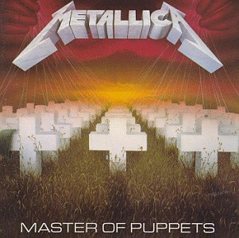

Gangland by: Iron Maiden
Shadows may hide you but also may be your grave
You're running today maybe tomorrow you'll be saved
You pray for daylight to save you for a while
You wonder if your children will face the killer's smile
Dead men -- tell no tales
In Gangland -- murder's up for sale
Dead men -- tell no tales
In Gangland -- where jail birds die
Face at the window leers into your own
But it's only your reflection still you tremble in your bones
How long can you hide? How long till they come?
A rat in a trap but you've got to survive
Once you were glad to be free for a while
The air tasted good and the world was your friend
Then came the day when the hard times began
Now your alone but alive for how long?
A knife at your throat another body on the pile
A contract to keep and it's service with a smile
Murder for vengeance or murder for gain
Death on the streets or a blackened out jail
Dead men -- tell no tales
In Gangland -- murder's up for sale
Dead men -- tell no tales
In Gangland -- where jail birds die
In Gangland you tell no tales

Angel of Death by: Slayer
Auschwitz, the meaning of pain
The way that I want you to die
Slow death, immense decay
Showers that cleanse you of your life
Forced in
Like cattle
You run
Stripped of
Your life's worth
Human mice, for the Angel of Death
Four hundred thousand more to die
Angel of Death
Monarch to the kingdom of the dead
Sadistic, surgeon of demise
Sadist of the noblest blood
Destroying, without mercy
To benefit the Aryan race
Surgery, with no anesthesia
Feel the knife pierce you intensely
Inferior, no use to mankind
Strapped down screaming out to die
Angel of Death
Monarch to the kingdom of the dead
Infamous butcher,
Angel of Death
Pumped with fluid, inside your brain
Pressure in your skull begins pushing through your eyes
Burning flesh, drips away
Test of heat burns your skin, your mind starts to boil
Frigid cold, cracks your limbs
How long can you last
In this frozen water burial?
Sewn together, joining heads
Just a matter of time
'Til you rip yourselves apart
Millions laid out in their
Crowded tombs
Sickening ways to achieve
The holocaust
Seas of blood, bury life
Smell your death as it burns
Deep inside of you
Abacinate, eyes that bleed
Praying for the end of
Your wide awake nightmare
Wings of pain, reach out for you
His face of death staring down,
Your blood running cold
Injecting cells, dying eyes
Feeding on the screams of
The mutants he's creating
Pathetic harmless victims
Left to die
Rancid Angel of Death
Flying free
(LEADS: HANNEMAN, KING, HANNEMAN, KING, HANNEMAN)
Angel of Death
Monarch to the kingdom of the dead
Infamous butcher,
Angel of Death
Angel of Death
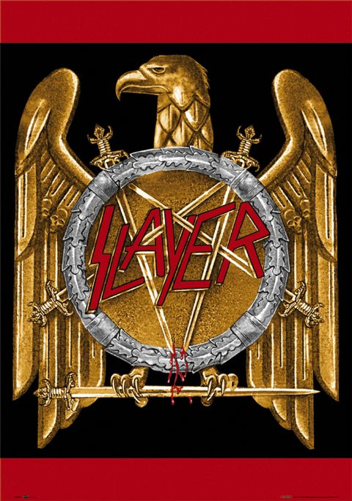
Aces High by: Iron Maiden
There goes the siren that warns of the air raid,
Then comes the sound of the guns sending flak.
Out for the scramble we've got to get airborne,
Got to get up for the coming attack.
Jump in the cockpit and start up the engines,
Remove all the wheelblocks there's no time to waste.
Gathering speed as we head down the runway,
Got to get airborne before it's too late.
Running, scrambling, fire,
Rolling, turning, diving, going in again.
Running, scrambling, fire, Rolling, turning, diving,
Run, live to fly, fly to live, do or die.
Won't you run, live to fly, fly to live, Aces high!
Move in to fire at the mainstream of bombers,
Let off a sharp burst and then turn away.
Roll over, spin round to come in behind them,
Move to their blindsides and firing again.
Bandits at 8 O'clock move in behind us,
Ten ME-109s out of the sun.
Ascending and turning our spitfires to face them,
Heading straight for them I press down my guns.
Rolling, turning, diving,
Rolling, turning, diving, going in again.
Rolling, turning, diving, Rolling, turning, diving,
Run, live to fly, fly to live, do or die.
Won't you run, live to fly, fly to live, Aces high!!!
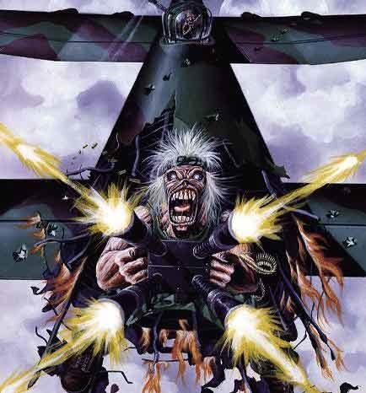

Rust In Peace...Polaris by: Megadeth
Tremble you weakings, cower in fear
I am your ruler, land, sea and air
Immense in my girth, erect I stand tall
I am nuclear murderer I am Polaris
Ready to pounce at the touch of a button
My systems locked in on military gluttons
I rule on land, air and sea
Pass judgement on humanity
Winds blow from the bowels of hell
Will we give warnings, only time will tell
Satan rears his ugly head, to spit into the wind
I spread disease like a dog
Discharge my payload a mile high
Rotten egg air of death wrestles your nostrils
Launch the Polaris, the end doesn't scare us
When will this cease
The warheads will all rust in peace
Bomb shelters filled to the brim
Survival such a silly whim
World leaders sell missiles cheap
Your stomach turns, your flesh creeps
High priests of holocaust, fire from the sea
Nuclear winter spreading disease
The day of final conflict
All pay the price
The third world war
Rapes peace, takes life
Back to the start, talk of the part
When the Earth was cold as ice
Total dismay as the sun passed away
And the days where black as night
Eradication of Earth's
Population loves Polaris

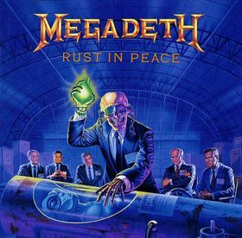

One by: Metallica
I can't remember anything
Cant tell if this is true or dream
Deep down inside I feel to scream
This terrible silence stops me
Now that the war is through with me
Im waking up I can not see
That there is not much left of me
Nothing is real but pain now
Hold my breath as I wish for death
Oh please god,wake me
Back in the womb its much too real
In pumps life that I must feel
But cant look forward to reveal
Look to the time when Ill live
Fed through the tube that sticks in me
Just like a wartime novelty
Tied to machines that make me be
Cut this life off from me
Hold my breath as I wish for death
Oh please god,wake me
Now the world is gone Im just one
Oh god,help me hold my breath as I wish for death
Oh please God help me
Darkness imprisoning me
All that I see
Absolute horror
I cannot live
I cannot die
Trapped in myself
Body my holding cell
Landmine has taken my sight
Taken my speech
Taken my hearing
Taken my arms
Taken my legs
Taken my soul
Left me with life in hell
