Parenting | Ben and Leslie Cash | Dave and Harper
 |  | 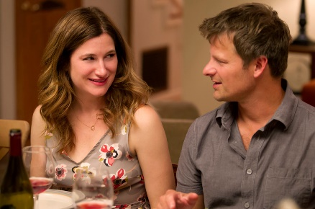
Openess | - Very open with the fact that his wife killed herself, does nothing to water down the cold hard facts.  - He is open about sex and rape  - Open about nudity and natural things in life  - Doesn’t believe in lying about the truth  - Swears and curses | - Open about technology and the popular culture.  - Let them play videogames and violent ones at that  - They tell about the aunt’s death couched in euphemisms and beating around the bush  - The full truth will scar their kids rather than help them
Shelters kids from | - Typical life and culture  - They don’t have to live in society  - Doesn’t want his kids to go to college  - Kids are illiterate to the popular culture  - Don’t know anything about anything unless it comes from a f---ing book | - Shelther the kids from the cold hard truth, including the cause and method of Leslie’s death
School | - He’s very strong about them knowing philosophy, history, and older more classical kinds of education.  - They are critical thinkers | - Justin and Jackson are typical teenagers  - Apathetic and so on
Option 1 of 5  Opinion ESSAY  Exam Question | Bodevan: I know nothing! I know nothing! I am a freak because of you! You made us freaks! And mom knew that! She understood! Unless it comes out of a f**ing book, I don't know anything about anything!  Harper: I'm sorry it doesn't live up to your high standards!  Ben: I tell the truth to my kids. I don't lie to my kids.  Harper: Protecting children from certain concepts that they are too young to understand is not lying to them!  Leslie: What we’re doing out here is so incredible. The kids are amazing.  Is Ben Cash a good father? Is he creating amazing kids unique and brilliant geniuses or sheltered freaks unable to face the ‘real world’  Ultimately what makes a good Parent?

